Junior Division (7-9) | Senior Division (10-12)

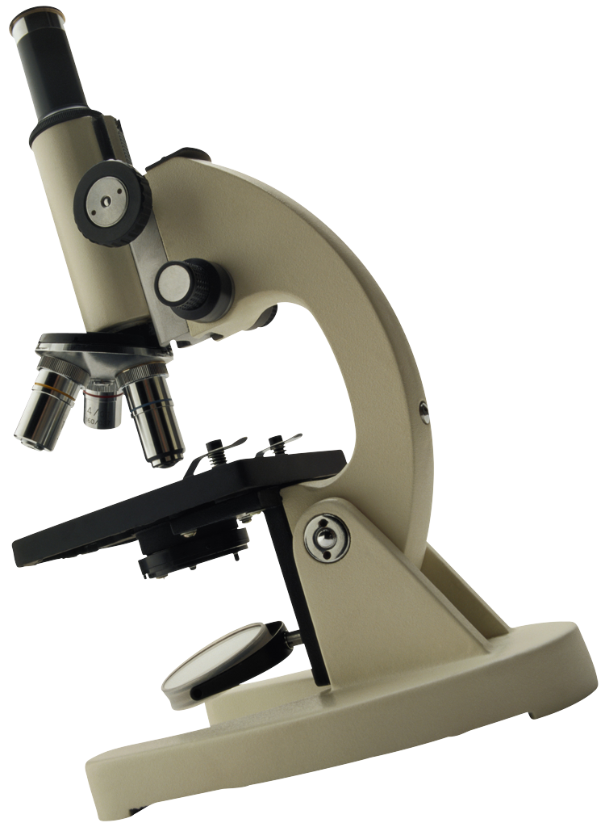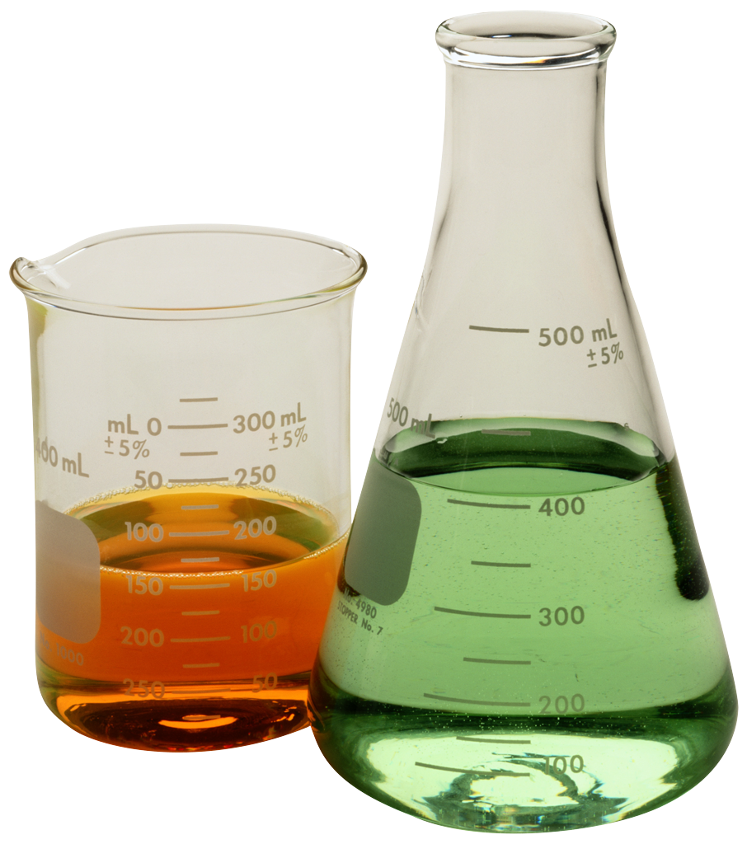

Biochemistry
Botany
Chemistry
Computer Science
Earth and Space Science
Engineering
Environmental Sciences
Physics
Zoology

Contact Brianne Eatchel
Phone: (555) 111-2222
Email: BrianneEatchel@swsu.edu

